**PROJECT STRUCTURE**

* Inside the Flight Booking app directory, we have the following folders

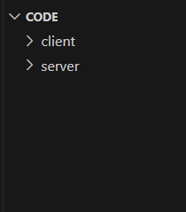

* **Client directory:**

The below directory structure represents the directories and files in the client folder (front end) where, react js is used along with Api’s.

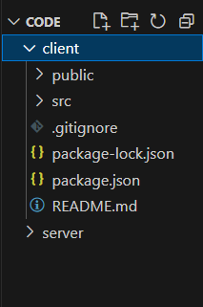

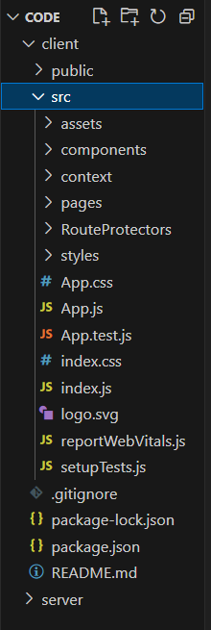

* **Server directory:**

The below directory structure represents the directories and files in the server folder (back end) where, node js, express js and mongodb are used along with Api.

